Sixth Form
Taster Days 2026

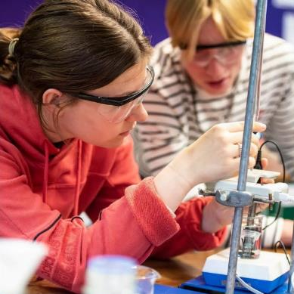
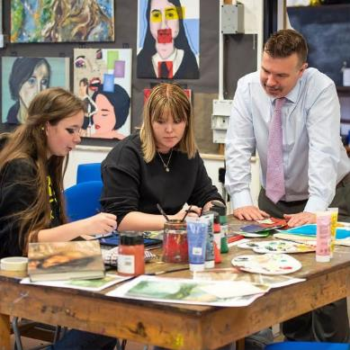
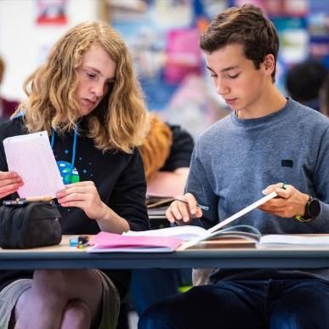
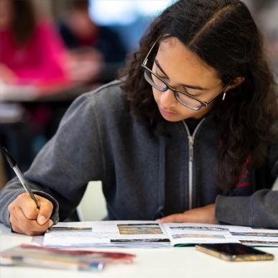
Name:
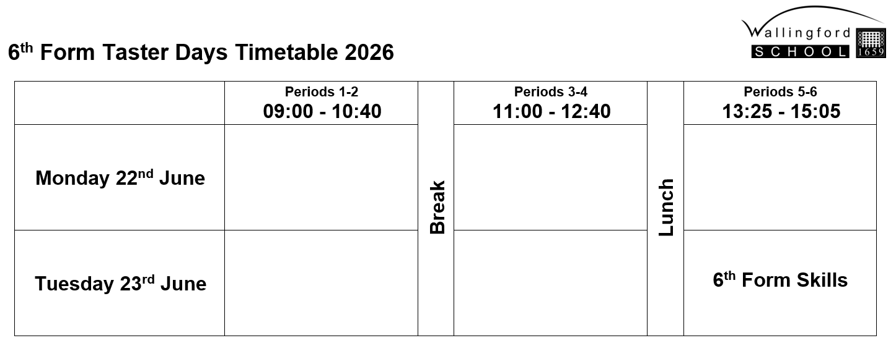

Taster Days and Summer Preparation work

Welcome to Wallingford Sixth Form Taster Days, which are your opportunity to experience life in our sixth form, to help you make some final decisions about the subjects you would like to study and to provide you with materials to prepare for your Sixth Form studies.
Over the next two days, you will go to taster lessons for the subjects you have expressed an interest in. For each of these sessions, you will be issued with some summer preparation work.
The aims of this work are:
- To prepare you for the level and nature of the work for the course
- To engage your interest and maintain your skills level over the summer months. You are expected to start Sixth Form where you left off at GCSE.
- For staff to gain an insight into your work ethics and your potential in each subject.
You will be given detailed information and clear deadlines for this work which can also be accessed on the Wallingford VLE. You can access the VLE via the Wallingford School website.
Study Sessions and Laptops
Additionally, across these Taster Days, you may have some “Study Periods”. In this time, we have allocated some activities for you to complete in the Sixth Form Common Room, these are detailed in the rest of this booklet. For some of these tasks you will need to access the internet. If you would like to use a Wallingford School laptop and do not have/cannot remember your login details, please use the guest details below:
Laptop Username: open Password: wallingford
Full Timetable:
Date | Periods | Subject | Staff | Room
Monday 22nd June | 1 & 2  Block B | Business Studies | Mr Flanagan | W12
Monday 22nd June | 1 & 2  Block B | Chemistry | Ms Jones | S2
Monday 22nd June | 1 & 2  Block B | English Literature | Ms Rice & Ms Harding | M9 & M12
Monday 22nd June | 1 & 2  Block B | Geography | Mr Jackson & Mr Pring | W16
Monday 22nd June | 1 & 2  Block B | Psychology | Mr Leigh | 6th Form
Monday 22nd June | 1 & 2  Block B | Mathematics | Mrs Beaumont | K8
Monday 22nd June | 1 & 2  Block B | Core Maths | Ms Pratt | K9
Monday 22nd June | 3 & 4  Block E | Chemistry | Ms Jones | S2
Monday 22nd June | 3 & 4  Block E | Further Maths | Ms Jones | K7
Monday 22nd June | 3 & 4  Block E | Politics | Ms Mummery & Mr Jackson | W3 & W11
Monday 22nd June | 3 & 4  Block E | Physical Education | Mr Dodson | W8
Monday 22nd June | 3 & 4  Block E | Psychology | Mr Leigh | 6th Form
Monday 22nd June | 3 & 4  Block E | Sport Studies BTEC | Ms Dudding | W6
Monday 22nd June | 5 & 6  Block C | Biology | Mrs Griffiths | S4
Monday 22nd June | 5 & 6  Block C | Art | Mr Hinchliffe | D3
Monday 22nd June | 5 & 6  Block C | Business Studies | Ms McGowan | W14
Monday 22nd June | 5 & 6  Block C | Maths | Ms Jones | K7
Monday 22nd June | 5 & 6  Block C | Music | Ms Hammond & Mr Young | K2
Monday 22nd June | 5 & 6  Block C | Philosophy, Religion and Ethics | Miss Elkington | W11
Tuesday 23rd June | 1 & 2  Block A | Biology | Ms White | S7
Tuesday 23rd June | 1 & 2  Block A | German | Ms Murison | K13
Tuesday 23rd June | 1 & 2  Block A | French | Ms McGarrick | D6
Tuesday 23rd June | 1 & 2  Block A | Health & Social Care | Mrs Burns | B7
Tuesday 23rd June | 1 & 2  Block A | Product Design | Mr Holden | T2b
Tuesday 23rd June |  | Physics | Mr Payne | W5
Tuesday 23rd June |  | Photography | Mr Bowen | D3
Tuesday 23rd June | 3 & 4  Block D | Applied Science | Mr Boerddart | S6
Tuesday 23rd June | 3 & 4  Block D | Geography | Miss Tommy Lee & Mr Jackson | W16
Tuesday 23rd June | 3 & 4  Block D | History | Mrs Jones & Ms Simpkins | W2 & W4
Tuesday 23rd June | 3 & 4  Block D | Maths | Mrs Ramsay | K10
Tuesday 23rd June | 3 & 4  Block D | Media Studies | Ms Howard-Saunders | B7
Tuesday 23rd June | 3 & 4  Block D | Physics | Mr Payne | W5
Tuesday 23rd June | 3 & 4  Block D | Textiles | Mrs Harper | T5
Tuesday 23rd June | 5 & 6 | Team Building Activities |  | Sixth Form

A Guide to Sixth Form Life And Successful Study Periods

Study Periods:
There are 30 periods on your timetable. You study a minimum of 3 courses, each with 5 periods per week. You will have 1 PSHE session and at least 1 ‘community’ period.
30 – 15 – 1 – 1 = 13 independent study periods a week
You will have homework set in a ratio of 1:1 (minimum one hour of homework per period). This means you have a minimum of five hours of homework per week per subject. You should also be completing one ‘reading hour’ per week in school.
Using your Study Periods effectively will ensure you have more free time outside of school hours. During your study periods on these two taster days, please use the following suggestions to structure your time, and get a taste of next year.
- Two videos to help you to study efficiently:




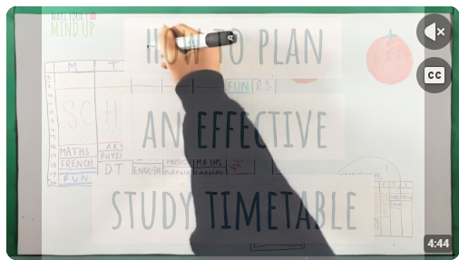

- Independent Learning Self-Assessment:
It is expected that you are able to complete work independently whilst you are at Wallingford Sixth Form. The aim of this questionnaire is to help you think about your approach to learning. Complete it honestly to discover how independent a learner you really are:
Self-Motivation
Score 1 | Score 2 | Score 3 | Score 4
I always need teachers to motivate me to learn | I often need teachers to motivate me to learn | I often motivate myself to learn | I always motivate myself to learn
Concentration in class
Score 1 | Score 2 | Score 3 | Score 4
I always need the threat of punishment to make me concentrate in class | I sometimes need the threat of punishment to make me concentrate in class | I often concentrate in class and do so because I am motivated to learn | I always concentrate in class and do so because I am motivated to learn
Becoming a better learner: Research and wider reading
Score 1 | Score 2 | Score 3 | Score 4
I believe it is my teachers’ job to ensure I learn all the correct material during lesson time | If my teacher tells me to do specific work outside of lessons I will sometimes do that too | I will use reading lists and web resources to extend the learning done in lesson time | I will use reading lists and web resources to extend my learning and ask for additional sources of information on topics that I find difficult or interesting
Becoming a better learner: New Techniques
Score 1 | Score 2 | Score 3 | Score 4
I am not keen to try new techniques | I will only try a new technique if I don’t currently have a technique that works for me | I will sometimes try new techniques | I will always try new techniques
Becoming a better learner: Study outside of lessons
Score 1 | Score 2 | Score 3 | Score 4
I always find it hard to work outside of lessons | I sometimes find it hard to work outside of lessons | Most of the time I find the time and motivation to study outside of lessons | I always find the time and motivation to study outside of lessons

Becoming a better learner: Missed work
Score 1 | Score 2 | Score 3 | Score 4
If I missed a lesson, I would always need a teacher to force me to catch up with the missing work | If I missed a lesson, I would sometimes always need a teacher to force me to catch up with the missing work | In most cases, if I missed a lesson, I would find out the missed work and try to catch up without being told by a teacher | In all cases, if I missed a lesson, I would find out the missed work and try to catch up without being told by a teacher
Organisation
Score 1 | Score 2 | Score 3 | Score 4
I always find it hard to organise myself to study – planning for deadlines, keeping my notes in order | I sometimes find it hard to organise myself to study – planning for deadlines, keeping my notes in order | I organise myself most of the time – I meet most deadlines and keep my notes in order | I organise myself all of the time – I meet most deadlines and keep my notes in order
Reflection: Questioning
Score 1 | Score 2 | Score 3 | Score 4
I never question what I am told by a teacher or that I read in books | I rarely question what I am told by a teacher or that I read in books | I sometimes question what I am told by a teacher or that I read in books | I always question what I am told by a teacher or that I read in books
Reflection: Seeking support
Score 1 | Score 2 | Score 3 | Score 4
I rarely seek support if I need it | I sometimes seek support if I need it | I often seek support if I need it | I always seek support if I need it
Attendance and punctuality
Score 1 | Score 2 | Score 3 | Score 4
I always need the threat of punishment to motivate me to turn up to lessons and on time | I sometimes need the threat of punishment to motivate me to turn up to lessons and on time | I rarely need the threat of punishment to motivate me to turn up to lessons and on time | I never need the threat of punishment to motivate me to turn up to lessons and on time
The Future
Score 1 | Score 2 | Score 3 | Score 4
I can’t see how any of my subjects will help me in the future | Some of my subjects will help me in the future, those are the only ones I’m interested in | I can see how my subjects will help me in the future | I can see how my subjects will help me in the future and I am really interested in them all

Total Score:………………/44

Your Score | Comment about independent learning
11 | You show little indication of any independent learning skills and you currently need to be forced to study. You need to consider what you want from your studies and what will motivate you to reach your potential in them!
12-22 | You may have some independent learning skills by you still require too much control by others to study. You need to consider the courses you are choosing and what goals you need to achieve in order to be successful.
23 – 33 | Well done. You show increasing signs of being self-motivated and in control of your own learning, especially with a score of between 28 – 33.  You still have some areas to improve, look back at your answers and consider what would help you to be more independent in those areas.
34 – 44 | Brilliant! You appear to be motivated to learn without needing close supervision and direction. You have developed good skills and are open to developing them further in order to be a highly successful student.

Reflecting on my Independent Learning skills:
What do I do well?

What do I need to improve?

What will I do to make this change?

- Conversations with Year 13:
Join the group of current sixth form students on the sofas in the Sixth Form Common Room.
This is your opportunity to ask any questions about 6th Form life at Wallingford School:
Find out what their biggest surprise has been this year.
Ask about their best memory of Sixth Form.
Discover what they wish they had known before they started!

- Putting study skills into practice:
From your conversations with Year 13s, the suggested videos, and the questionnaire, you should now have an idea of what is expected during Study Periods. There is no time like the present to put them into practice!
- Choose a lesson that you went to yesterday or this morning and review the topics and content covered.
- The next 4 pages have lots of suggestions for how to review what you have covered. Try a blend of some you have tried before, as well as some new techniques.
Please complete this activity for at least 2 of your lessons, remember: the retrieval is most effective for lessons completed the day before (rather than the last lesson you went to!)

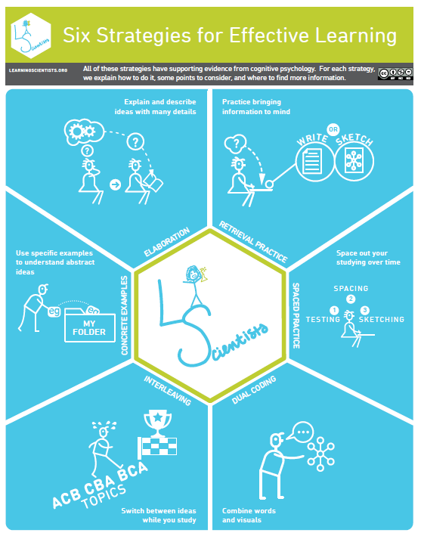

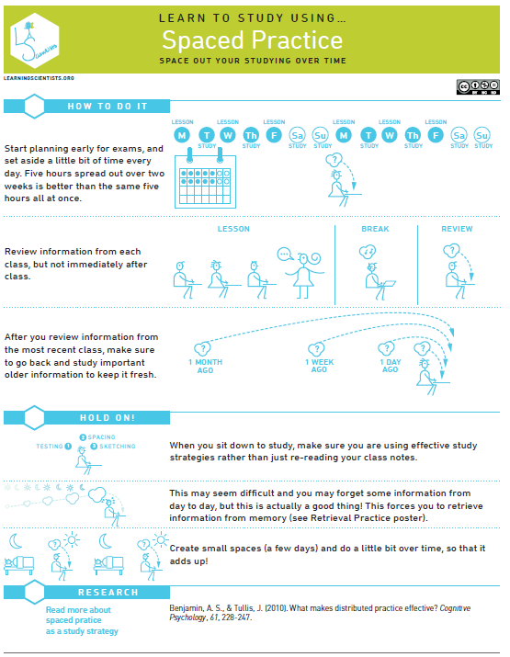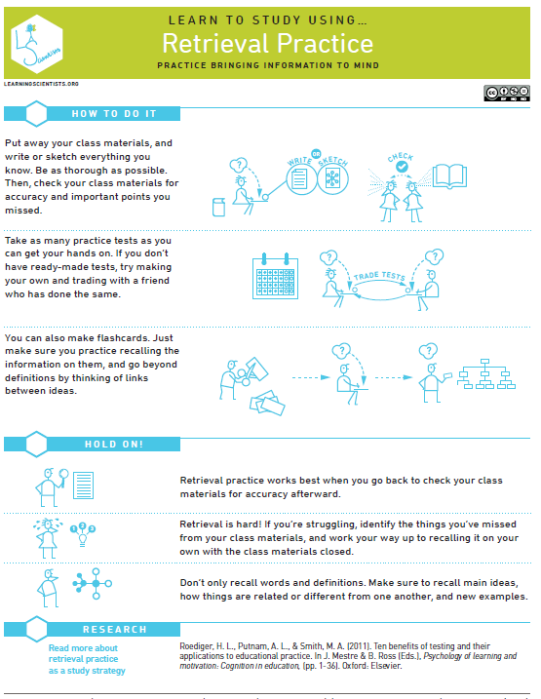
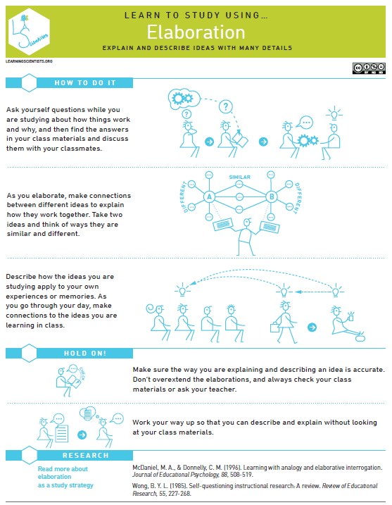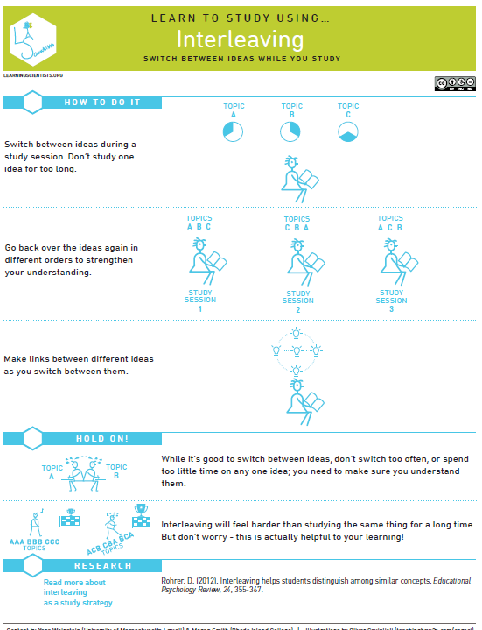
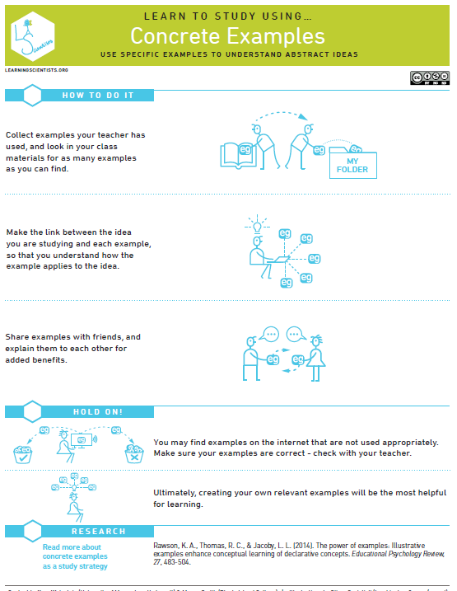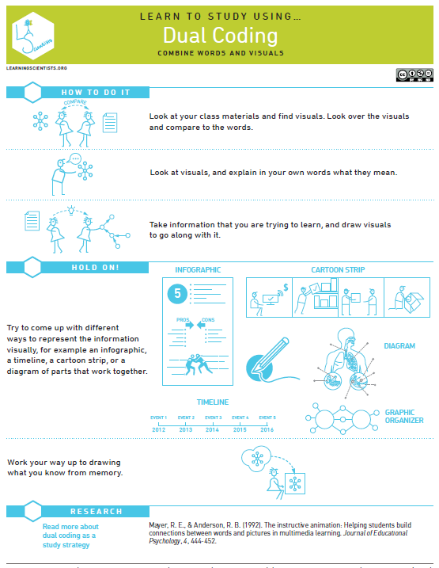
- Life after 

While working towards your A Levels / BTECs it is important to have your next steps in mind.

Which of the following have you considered?
Write down your initial thoughts in one or more areas

Getting a job | Getting an apprenticeship | Going to college/university
Possible career options  …………................................  …………................................  …………................................  …………................................  …………................................  …………................................  …………................................ | Possible apprenticeship options  ………….................................  ………….................................  ………….................................  ………….................................  ………….................................  ………….................................  …………................................. | Possible course choices  ………….................................  ………….................................  ………….................................  ………….................................  ………….................................  ………….................................  ………….................................

There are many websites that will help you research your ideas, even at this early stage.

As a start, consider using…

http://www.apprenticeships.org.uk
…to find out about possible apprenticeships

http://search.ucas.com
…to find a university, a course and the grades you would need at A-Level

http://university.which.co.uk
…to find a university and a course

https://www.theuniguide.co.uk/advice/choosing-a-course/what-is-the-russell-group
…to look up which universities are in the Russell Group and why you might apply

http://www.notgoingtouni.co.uk/
…to find out about other opportunities that you might want to consider

http://www.sfengland.slc.co.uk/
…to find out about how you can get funding for further study

Website visited: …………………………………………………
What I found out (grade offers / requirements / features):

……………………………………………………………………………..…………..........................

……………………………………………………………………………..…………..........................

……………………………………………………………………………..…………..........................

……………………………………………………………………………..…………..........................

Website visited: …………………………………………………
What I found out (grade offers / requirements / features):

……………………………………………………………………………..…………..........................

……………………………………………………………………………..…………..........................

……………………………………………………………………………..…………..........................

……………………………………………………………………………..…………..........................

Website visited: …………………………………………………
What I found out (grade offers / requirements / features):

……………………………………………………………………………..…………..........................

……………………………………………………………………………..…………..........................

……………………………………………………………………………..…………..........................

……………………………………………………………………………..…………..........................

6. Summer of 2026
A) Subject Summer Work
Throughout all of the tasks you have completed in your Study Periods on these Taster Days, the key theme has been getting organised. So, it is now time to organise your summer too!
Using the skills from the scheduling videos and the monthly planners on the next pages, fill in all of the deadlines for your subject summer work. Block off any time that you know you cannot do work: holidays, work experience, festivals etc., and then fill in times when you will complete the tasks you have been set.
B) Preparing for Year 12
This summer is a fantastic opportunity to prepare for 6th Form and to complete some additional activities that will put you in a strong position going forward. Use the prompts below to consider how you might use your time.
MOOC – What is it? (Google it!) What can I do it on? What’s the point?

Reading – Which books can I read to give me a headstart for 6th form?

Work Experience – Can I get some this summer? Where? When?

Your First Day at 6th Form – Thursday 3rd September 2026

8.35am Students arrive on site
8.40am Registration
9.00am Period 1
9.50am Period 2
10.40am Break
Thursday 3rd September - Induction Day

Registration, and Periods 1-4 will be used to issue timetables, meet your tutors, have your 6th Form Induction, and to get to know your new tutor group.
During Periods 5 & 6 you will follow your new timetable. Please come to school with standard equipment and stationery. Your teachers will give subject specific instructions regarding folders and such things.
If you have Study Periods during P5 & 6, Study Tasks will be set to help you make a positive start to your lessons.

11.00am Period 3
11.50am Period 4
12.40pm Lunch
1.25pm Period 5
2.15pm Period 6
3.05pm End of the day

Lunch
There is lots of space to enjoy a packed lunch, and Sixth Form students are allowed the privilege of being able to leave the school site at lunch time if you wish. Please return promptly for 1.20pm. Students are not allowed off the school site at break time or during study periods or lessons.
Mobile phones
Throughout the school, students are not allowed to use their mobile phones and they are confiscated if seen, and can be collected at the end of the day. Whilst we know that Sixth Form students are able to use their phones sensibly, this rule does apply to students in Year 12 and 13 except for if they are used in the Sixth Form Centre. As role models, it is important that you are seen to be modelling excellent behaviour around the school. Your teachers may also allow you to use your phone in lessons, but you should not use them unless the teacher has said so.
Dress code
Sixth formers have the privilege of wearing their own clothes to 6th Form that are suitable for study in a school. For clarity, here are the key things from our dress code:
- In lessons, no outdoor clothing should be worn, e.g. hats, coats, gloves or scarves. Headwear should not be worn indoors (unless for religious or medical reasons). This includes hoods.
- Writing or logos on clothes should not be offensive.
- Tops should be worn at all times and must not be strapless.
- Tops should not have a low cut neckline, so that the chest area is covered, nor should they have wide armholes that expose the torso.
- Tops should be long enough to cover stomach and bottoms should be high enough to cover underwear.
- All bottoms should be at least in line with your hands when standing upright.
- There are footwear rules in certain lessons due to health and safety issues. Generally speaking comfortable flat footwear is advised but sliders and flip flops are too casual.
Behaviour
We need to be mindful of younger students and our position as role models at the top end of the school. We ask that sixth formers do not walk around school carrying cans of drink, such as energy drinks.
Smoking and vaping is banned throughout the school site for all students including sixth form students. Alcohol and chewing gum are also banned from the school site.
Unacceptable Behaviour
We pride ourselves on having an inclusive Sixth Form where everyone feels welcome, respected and safe. We do not tolerate any kind of physical or verbal abuse nor any sexual, racial or homophobic or gender based harassment. We will always take such incidents seriously, so please tell a member of staff if you see, hear or experience any abuse or harassment. Your subject teachers, Sixth Form Team or any member of SLT will listen to your concerns and we also have a GET HELP button on our website homepage which will allow you to email gethelp@wallingfordschool.com
Important Dates:

GCSE Results Day & 6th Form Enrolment Day : Thursday 20th August
The Sixth Form common room will be open between 10.00am and 12.00pm.
Refreshments will be available from 9.30am.

6th Form Drop-In Clinic to confirm your options and enrol: Friday 21st August
No appointment is necessary, just turn up between 9am and 1pm to meet with
a member of the Sixth Form or Senior Leadership Team.

If you can’t make it to the clinic, Mr Holton will be available for limited conversations on Results Day.

1st Day of School for Year 12 – Thursday 3rd September


Year 12 Introduction to 6th Form Evening – Thursday 10th September (FOR PARENTS & GUARDIANS)

Address: Wallingford School, St George's Road, Wallingford, Oxon, OX10 8HH

Email:office.4140@wallingfordschool.com Telephone: 01491 837 115

Facebook: www.facebook.com/wallingford4140 Twitter: twitter.com/wallingford4140

Address: Wallingford School, St George's Road, Wallingford, Oxon, OX10 8HH

Email:office.4140@wallingfordschool.com Telephone: 01491 837 115

Facebook: www.facebook.com/wallingford4140 Twitter: twitter.com/wallingford4140

EPQ
There is the opportunity to complete a qualification in Year 12 called the Extended Project Qualification (EPQ).
This is a research project on a subject of your choice.
It is completed in Year 12, graded A* to E, and is the equivalent of half an A Level.
Universities sometimes offer lower entry grades if a certain grade is attained at EPQ as they know that students who have completed the qualification have advanced research, planning, writing, recording, reporting and reflection skills.
You can explore a research question on any topic, as long as it is not something you will be directly taught in your A Level of BTEC courses.
You produce a log, recording your planning, research, progress, problems and solutions and reflections on your work. You also produce an essay or an artefact with your findings.
If you interested in doing the EPQ, it will help if you spend some time considering your topic/question and beginning some research over the summer holidays. You will need to keep a record of the research as you go along – books, articles, websites etc.
Here are some questions which have been explored in the past year or so:
- Does Turmeric have healing powers?
- Who was responsible for Van Gogh’s death?
- How successful were William the Conqueror’s strategies in consolidating Norman Control over England and Wales?
- To what extent has archaeology shaped our understanding of daily life in Ancient Rom?
- Is there a relationship between rowing technique, energy efficiency and boat hydrodynamics in competitive rowing?
- Are the impacts of rising sea temperature on ocean diversity irreversible?
- In the reframing of the stories of Penelope, Medusa and Circe, were they shown as weak initially but do the feminist retellings now show different but evidenced views?
- To what extent does parenting styles affect emotional development in children?

If you are interested, try the following activities in study periods on taster days and over the summer:

- Look at the website for AQA Extended Project Qualification : Level Three Projects 7993 | Specification | AQA


- Download a copy of the log that needs to be filled in over the course of the qualification: Candidate record form, Production log and Assessment record 2026

- Make a list of the areas that you might want to explore:
Ideas for EPQ project | More focused question options | Where to research- experts, websites, books, articles…..


If you are thinking of doing the EPQ, look carefully at the earlier self-evaluation task and consider which of your strengths would be most useful for a project which is an independent task, with guidance but the onus is on you to complete the work withing the deadlines!
Any questions, email mummerya@wallingfordschool.com

Notes

School Map – Ground Floor

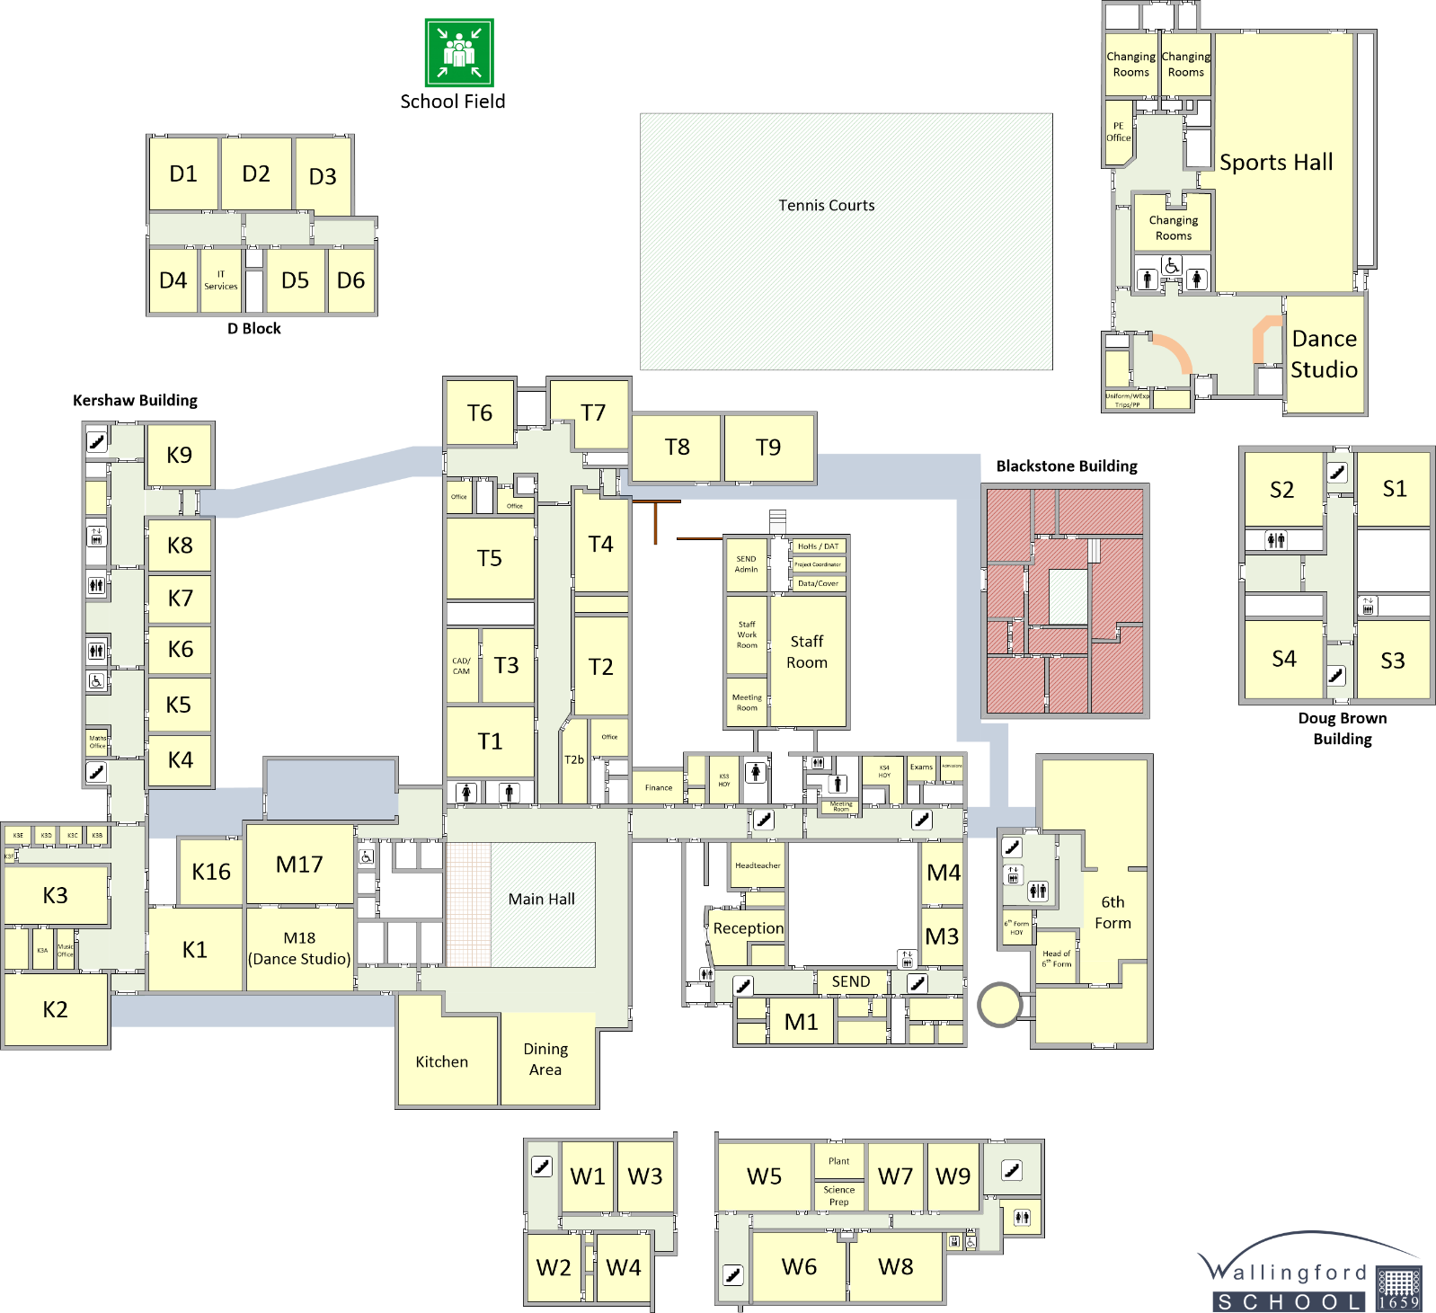
School Map – First Floor

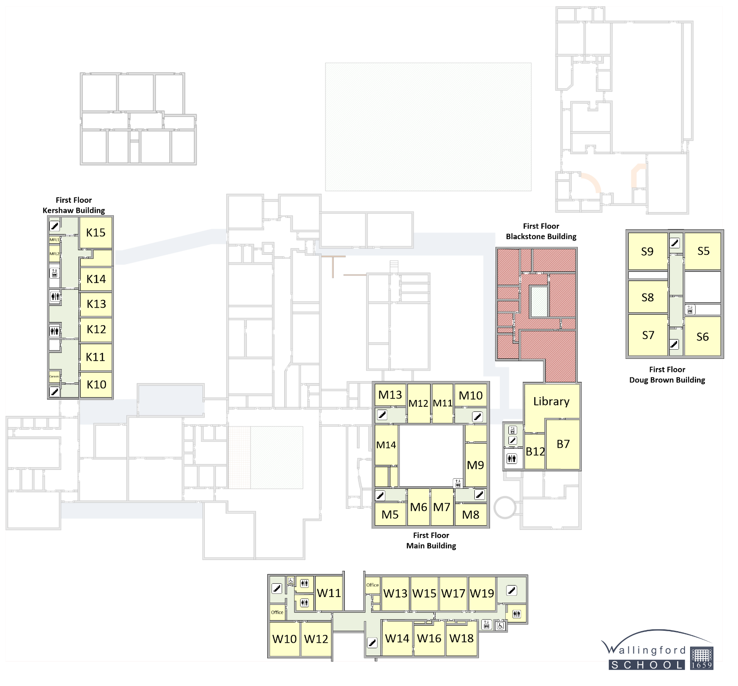

Address: Wallingford School, St George's Road, Wallingford, Oxon, OX10 8HH

Email:office.4140@wallingfordschool.com Telephone: 01491 837 115

Facebook: www.facebook.com/wallingford4140 Twitter: twitter.com/wallingford4140

